DISCLAIMER

This non-binding document has been developed by the TESIM project.

It does not necessarily reflect the views of the European Commission on the topic, and is presented to programme practitioners for illustrative purposes only.

A project funded by the European Union |  | Implemented by a consortium led by

Compliance assessment in

ENI CBC programmes

  - Guidance on methodology, designation criteria and audit opinion
  - Update June 2017
Content

1. Introduction 3
1.1. Legal framework 3
1.2. Aim of the document 4
1.3. Content of the document 5
1.4. Steps in the designation procedure 6
2. Methodology and steps for the assessment 6
3. Designation criteria 8
4. Evaluation of the designation criteria 11
4.1. Verification of the completeness of the documents submitted to the IAB 11
4.2. Internal control environment 12
4.3. Risk management 18
4.4. Management and control 20
4.5. Information and communication 36
4.6. Monitoring 39
4.7. Final checks 41
4.8. Overall assessment 42
5. Audit opinion 43
5.1. Type of opinions by the independent audit body 43
5.2. Summary table of the independent audit body 43
5.3. Model of audit report 45
5.4. Model of audit opinion 46

Clarification on update June 2017

The contents of the document originally delivered in March 2016 have been modified following the discussions which took place at the networking event for ENI CBC Audit Authorities, held in Warsaw on 8-9 March 2017.

The modifications correspond to the questions in the compliance check-list related to the criterion on monitoring internal control (pages 39 to 41).

Introduction

Legal framework
This guidance note has been built using the following legal base and guidance documents:
- Article 32 of the Financial Regulation (Regulation 966/2012)
- ENI CBC Implementing Rules, including the annex with the designation criteria (Regulation 897/2014), hereinafter ENI CBC IR
Moreover, the following legal documents and guidance notes have been used as a source of inspiration:
- Annex XIII – designation criteria – of Commission Regulation 1303/2013 (Common Provisions of Structural Funds)
- ToR for pillar assessments contracted by entities requesting to be entrusted with implementation of the EU budget under indirect management - guidance note. DEVCO.R2 Audit and Control
- EGESIF_14-0013 Guidance for Member States and Programme Authorities- Designation Procedure (under Articles 123 and 124 of Regulation (EU) No 1303/2013 and Article 21 of the Regulation (EU) No 1299/2013), especially the check list for assessing compliance of MCS
- EGESIF_14-0010 Guidance on a common methodology for the assessment of management and control systems in the Member States
The fundamental legal base for the designation in the ENI CBC IR is Article 25:

“1. The Managing Authority that has been selected by the participating countries of the programme shall undergo a designation procedure in the Member State in which it is located by decision at the appropriate level.
- The designation procedure shall be based on a report and an opinion of an independent audit body that assesses the compliance of the management and control systems, including the role of intermediate bodies therein, with the designation criteria laid down in Annex I to this Regulation. The audit body shall take into account, where relevant, whether the management and control systems for the programme are similar to those in place for the previous programming period, as well as any evidence of their effective functioning.

The independent audit body shall be the Audit Authority, or another public or private law body with the necessary audit capacity, which is functionally independent of the Managing Authority. It shall carry out its work in accordance with internationally accepted audit standards.
- The Member State shall submit the formal decision referred to in paragraph 1 to the Commission as soon as possible after the programme adoption by the Commission.

- Within two months of receipt of the formal decision referred to in paragraph 1, the Commission may request the report and the opinion of the independent audit body and the description of the management and control system as regards, in particular, those parts concerning project selection. If the Commission does not intend to request these documents, it shall notify the Member State as soon as possible. If the Commission requests these documents, it may make observations within two months of receipt of these documents which shall be reviewed taking into account the observations. When the Commission does not have any initial or further observations it shall notify the Member State as soon as possible.”
In accordance with article 4(b), the Joint Operational Programmes describe the designation procedure and identify the independent audit body responsible for issuing the report, as well as the national institution taking the formal decision.

Aim of the document
The aim of this document is to provide practical tools for the independent audit body (IAB) responsible for the assessment of the compliance of the management and control systems with the criteria defined in the annex of the ENI CBC Implementing Rules. Even though Member States have experience of the procedure in 2007-2013 for the Structural Funds, including European Territorial Cooperation, the current period is the first one with shared management in CBC programmes of the European Neighbourhood Instrument.

Guidance for the INTERREG programmes 2014-2020 can be a source of inspiration, especially for three of the criteria listed in the annex of the ENI CCB Implementing Rules, once adapted to the specific ENI CBC regulatory framework. Nevertheless, ENI CBC includes more criteria, linked to other components of internal control, as defined by INTOSAI GOV 9100 and the “Integrated Framework” of the Committee of the Sponsoring Organizations of the Treadway Commission (COSO).

Components of internal control (INTOSAI & COSO) | Criteria in Annex of ENI CBC Implementing Rules | Criteria in Annex XIII of the Common Provisions Regulation on ESIF
Control environment | - Internal control environment | - Internal control environment
Risk assessment | - Risk management | - Risk management
Control activities | 3. Management and control activities | - Management and control activities  - Monitoring
Information and communication | - Information and communication | Not included
Monitoring activities | - Monitoring | Not included
The components of information and communication and on monitoring indicated both in the INTOSAI / COSO Integrated Framework and ENI CBC Implementing Rules are referred to the internal control, not to the communication and monitoring activities of the programme requested by its articles 78 and 79 and included in the Joint Operational Programmes.
These components of the designation criteria have to be developed in the description of the management and control systems (DMCS).
Consequently, this guidance only takes into account the EGESIF guidance for criteria 1 to 3 of the ENI CBC annex and develops new tools for the other two.
Another difference is that ENI CBC assigns the managing and certifying functions to the Managing Authority, while INTERREG programmes usually have a Managing Authority and a Certifying Authority, which need to be included in the designation process.

Content of the document
As in the case of the EGESIF one, this guidance provides explanations and tools for:
- The methodology and steps to follow for the compliance assessment
- The key requirements indicated in the Annex of the Implementing Rules
- The assessment criteria for each key requirement in a check-list form
- The conclusions on each requirement
- The overall conclusions on the MCS and the audit opinion
Therefore, this guidance is mainly addressed to the independent audit body (IAB) responsible for the assessment, even though it can be also useful for the Managing Authority and other programme structures in the preparation of the DMCS or as a self-assessment tool. This guidance note is accompanied by a checklist and a model for the report and opinion on the compliance of the Managing Authorities with the designation criteria.

Steps in the designation procedure
In accordance with the above-mentioned article 25 of the ENI CBC Implementing Rules, in order to obtain the designation of the Managing Authority, once the programme is adopted, the following steps take place, taking into account that the observations by EC are optional:
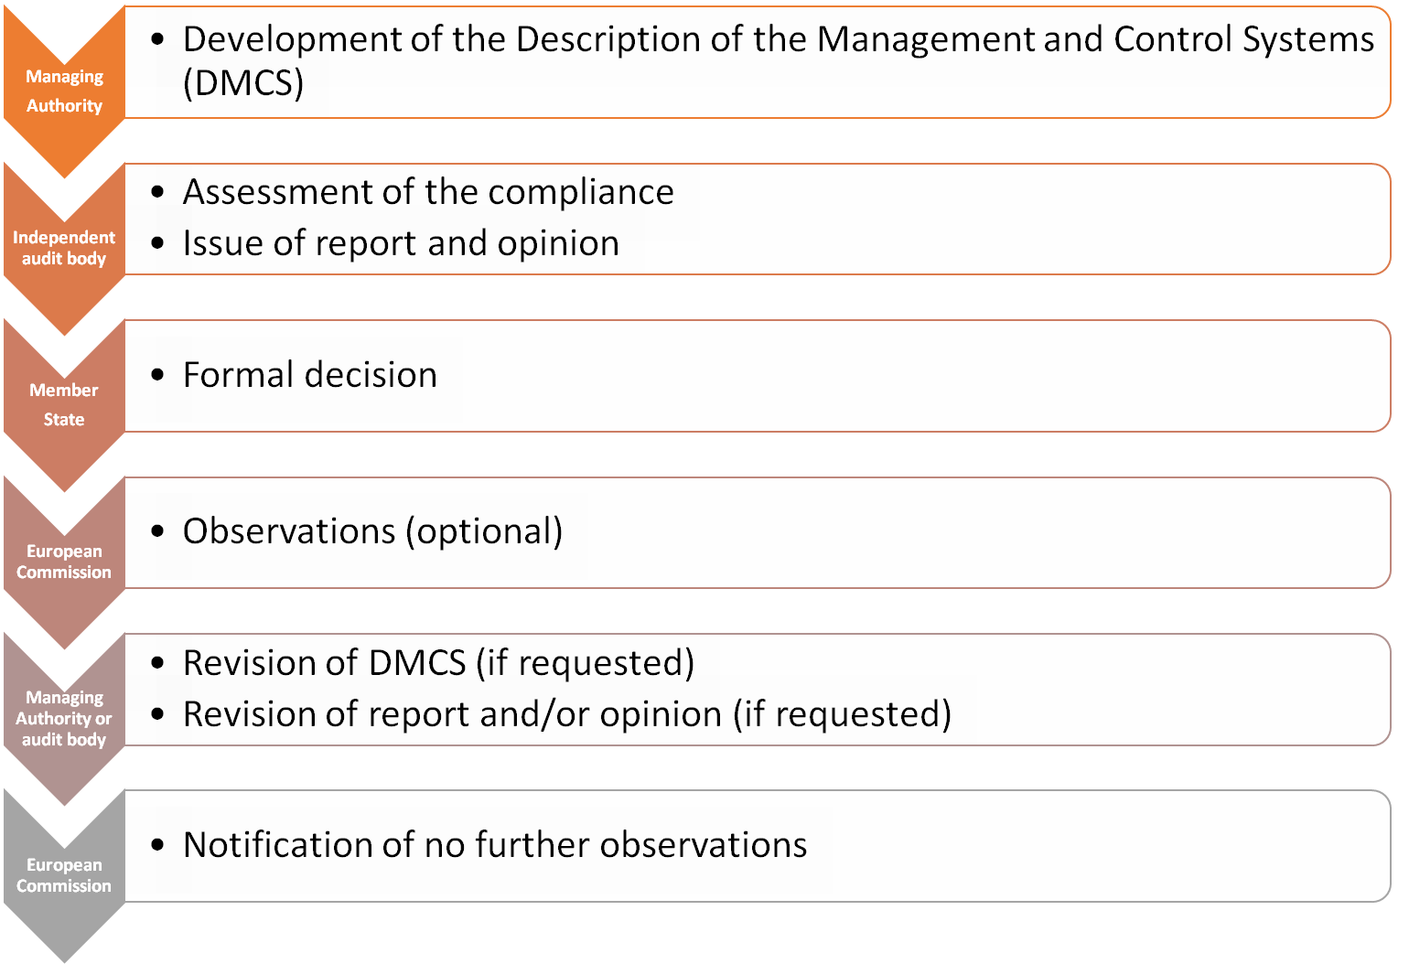

Methodology and steps for the assessment
This document includes the criteria for the assessment of the functioning of the MCS. The non-compliance with these criteria implies system deficiencies and thus a risk of irregular expenditure being certified to the European Commission and of over-financing made to the participating countries.
The IAB should have adequate time to complete the entire process of assessing compliance with the designation criteria, which includes the following phases:
- The receipt of the description of the functions and procedures in place for the MA and gathering other relevant documents.
- Analysis of data gathered, examination of the documents and performance of the audit work required, including where considered appropriate interviews with staff.
- Preparation of the report and opinion and the contradictory procedure, including validation of the findings and conclusions. Adequate time should be allocated to this procedure to allow the authorities assessed to respond to observations and provide additional information.
The IAB should make a first review to identify and prioritise the work to be performed, taking into account the existence of common systems for different programmes, the time and resources available for carrying out the assessment and any risks identified for particular programmes, authorities or other bodies, which should include the following elements:
- An examination of the systems description which should be in final form when the designation-related audit work starts. As setting up the systems and preparing the system description can sometimes be complex and lengthy, the IAB may decide to start its work on available parts of the description before finalisation of the entire document.

- The examination of relevant documents concerning the systems, such as code of ethics, job descriptions or manuals of procedure, including when relevant those of the institutions hosting the programme bodies.

- Interviews with the staff in the main bodies considered important. The IAB should indicate in the report the extent to which they performed interviews and specify the criteria for the selection of the interviewees.

- Verification of the consistency between the systems description and the explanations obtained in the course of the work carried out.
The IAB should describe in the report the extent and scope of the work performed and the methodology applied in order to reach its conclusions as a whole.
The assessment shall take the following steps:
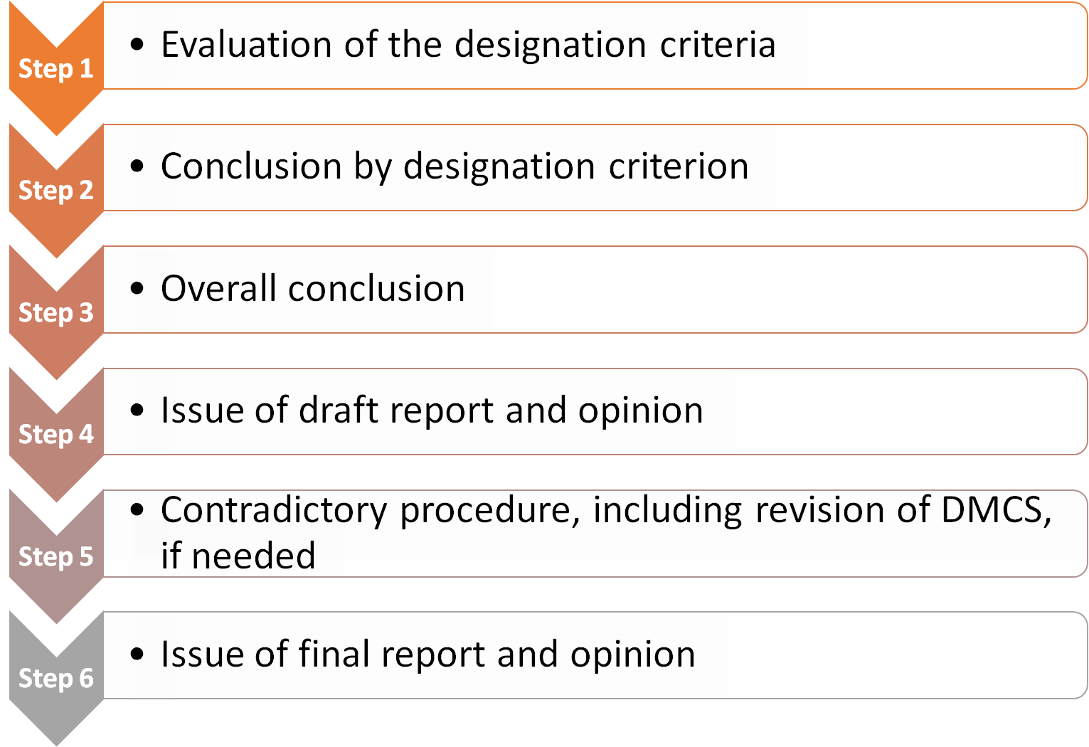

Designation criteria
The designation criteria are stipulated in the annex of the ENI CBC Implementing Rules, divided in the five components of internal control:
1. Internal control environment
- An organisational structure covering the functions of managing authority and the allocation of functions between and within each body as described in Chapter 2 of Title IV of Part Two, ensuring that the principle of segregation of functions, where appropriate, is respected.
- If delegation of tasks to intermediate bodies, a framework for ensuring the definition of their respective responsibilities and obligations, verification of their capacities to carry out delegated tasks and the existence of reporting procedures.
- Reporting and monitoring procedures for preventing, detecting and correcting irregularities and for recovering amounts unduly paid.
- Plan for allocation of appropriate human resources with necessary skills, at different levels and for different functions in the organisation.
2. Risk management
Taking into account the principle of proportionality, a system for ensuring that an appropriate risk management exercise is conducted at least once per year, and in particular, in the event of major modifications of the activities.
3. Management and control activities
- Project selection procedures, ensuring the principles of transparency, equal treatment, non-discrimination, objectivity and fair competition. With a view to respect these principles:
- the projects shall be selected and awarded on the basis of pre-announced selection and award criteria which are defined in the evaluation grid. The selection criteria serve to assess the applicant's ability to complete the proposed action or work programme. The award criteria are used to assess the quality of the project's proposal against the set objectives and priorities;
- the grants shall be subject to ex ante and ex post publicity rules;
- the applicants shall be informed in writing about the evaluation results. If the grant requested is not awarded, the Managing Authority shall provide the reasons for the rejection of the application with reference to the selection and award criteria that are not met by the application;
- any conflict of interest shall be avoided;
- the same rules and conditions shall be applied to all applicants.
- Contract management procedures.
- Verification procedures including administrative verifications in respect of each payment request by beneficiaries and the on-the-spot verifications of projects.
- Procedures for processing and authorising payments.
- Procedures for establishing a system to collect, record and store electronically data on each project and for ensuring that the IT systems are secured in line with internationally accepted standards.
- Procedures established by the managing authority to ensure that beneficiaries maintain either a separate accounting system or an adequate accounting code for all transactions relating to a project.
- Procedures for putting in place effective and proportionate anti-fraud measures.
- Procedures for drawing up the accounts and ensure that they are true, complete and accurate and that the expenditure complies with applicable rules.
- Procedures to ensure an adequate audit trail and archiving system.
- Procedures to draw up the management declaration of assurance, report on the controls carried out and weaknesses identified, and the annual summary of final audits and controls.
- Where tasks are delegated to intermediate bodies, the designation criteria should include an assessment of the procedures in place to ensure that the Managing Authority verifies the capacity of the intermediate bodies to carry out tasks and to monitor that these tasks are being properly implemented.
4. Information and communication
- The Managing Authority obtains or generates and uses relevant information to support the functioning of other components of the internal control.
- The Managing Authority internally disseminates information, including objectives and responsibilities for internal control, necessary to support the functioning of other components of the internal control.
- The Managing Authority communicates with external parties regarding matters affecting the functioning of other components of internal control.
5. Monitoring
Documented procedures, verifications and evaluations performed to ascertain that the components of internal control exist and function.

Evaluation of the designation criteria
The evaluation of the designation criteria is the base for the report and opinion by the IAB. Based on the international standards mentioned in chapter 1, this document includes key questions for each component of the internal control, as well as a check-list for the assessment of the compliance with the criteria for each component stipulated in the annex to the Implementing Rules:

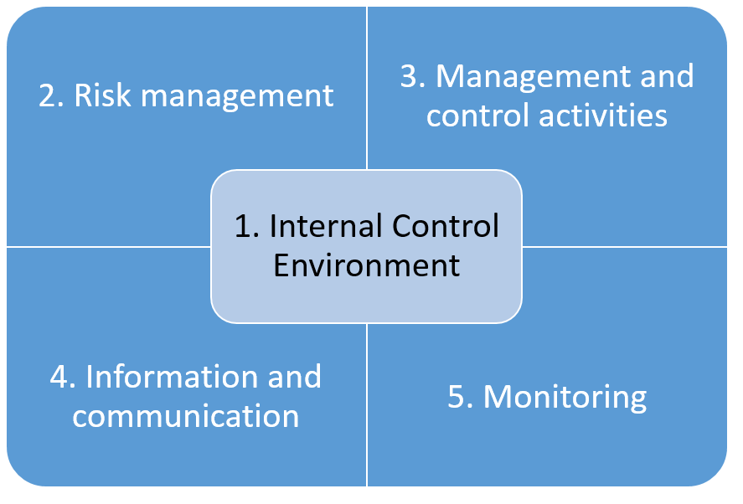
The final result of this audit work should lead to the answer to the following global key question:
Global key question
Has the Managing Authority set up set up and ensured the functioning in all material respects of an effective and efficient internal control system, in accordance with the criteria set by the European Commission in the Financial Regulation and the Implementing Rules?

Verification of the completeness of the documents submitted to the IAB
The evaluation needs to start with a verification of the completeness of the documents submitted to the IAB.

# | Source | Questions | YES/NO/Not Applicable | File reference, observation, comments, findings
0.1 | EGESIF_14-0013 | Has the Member State hosting the MA submitted to the IAB the Description of the Management and Control Systems (DMCS)?
0.2 | TESIM | Is the DMCS complemented with other documents, such as manuals of procedure, job descriptions, code of ethics, etc., which are referenced throughout the document?
 |  | Conclusion | Adequate/Not adequate

Internal control environment

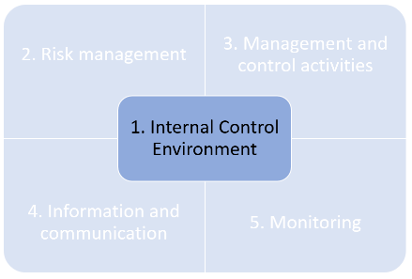 | Key question  Does the control environment of the Managing Authority provide an adequate basis for carrying out internal control across the organisation?  Note:  Control environment includes the governance and management functions and the attitudes, awareness and actions of those charged with governance and management concerning the MA’s internal control and its importance in the MA.

# | Source | Questions | YES/NO/Not Applicable | File reference, observation, comments, findings
 |  | Organisational structure | Criterion 1 (i)
1.1 | EGESIF_14-0013 | Is general information (as well as a flowchart) showing the organisational relationships between MA, JTS/BO, NA, CCP and the AA/GoA provided, including the reporting lines to the EC?
1.2 | EGESIF_14-0013 & TESIM | Have organisation charts been provided, covering:  - All functions of the MA, as described in Chapter 2 of the Title IV of Part Two of IR covered, as well as those of any intermediate body with delegated tasks?  - The allocation of functions within each authority and body, ensuring that the principle of separation of functions, where appropriate, is respected
1.3 | ToR pillar assessment Europeaid | Does the direction and the staff responsible for teams demonstrate a commitment to communicate and enforce integrity and ethical values?  - Are there any relevant laws, rules, codes and/or procedures for ethics and integrity policies that are communicated to all staff or a staff manual containing provisions promoting ethical behaviour and values, such as conflicts of interest (disclosure obligation), use of official information & public resources, receiving gifts or benefits, loyalty and confidentiality, etc...?  - Are these rules binding for the staff working in MA?  - Does the direction and the staff responsible for teams stress and communicate the importance of integrity and ethical values to staff (“tone at the top”)?
1.4 | ToR pillar assessment Europeaid | Are there procedures (e.g. disciplinary sanctions, financial and personal liability) for staff who do not comply with integrity rules and ethical values?
1.5 | EGESIF_14-0013 | Are there procedures to ensure that MA staff in sensitive posts (i.e. any posts whose occupant could cause adverse effect to the integrity and functioning of the institution by virtue of the nature of his/her responsibility) are identified and that appropriate controls (including, where appropriate, rotation and segregation of functions policies) are applied to such posts?
1.6 | EGESIF_14-0013 | Are there procedures in place to:  - Identify and avoid conflicts of interest through an adequate policy of separation of functions?  - Deal with possible conflicts of interest at decision-making level?
 |  | Delegation of tasks to intermediate bodies (IB) | Criterion 1 (ii) and criterion 3 (xi)
1.7 | EGESIF_14-0013 | Are there procedures for making available to the IB the information relevant to the execution of their tasks?
1.8 | EGESIF_14-0013 | Have all IB been formally appointed, in accordance with art. 20 of IR?  For those already appointed, confirm that relevant arrangements formally recorded in writing exist, describing the functions and tasks delegated by MA?  Are the respective responsibilities and obligations of MA and IB clearly stated in writing?
1.9 | EGESIF_14-0013 | Are the procedures in MA to supervise the implementation of the delegated functions appropriate?  Are there adequate procedures for reporting and monitoring between MA and IB on the basis of adequate reporting mechanisms (review of IB’s methodology, regular review of results reported by the IB, re-performance on a sample basis of work carried out by IB)?  Does MA monitor / verify whether conditions for internal control are respected?
1.10 | EGESIF_14-0013 | Is there an organisation chart describing the allocation of tasks between and within IBs, together with the indicative number of posts allocated?  Detail any problem arising from the analysis of the organisation chart
1.11 | EGESIF_14-0013 | Did MA verify the capacity (clearly defined responsibilities, clear organisation chart, etc…) of the IB to carry out the delegated tasks in relation to the selection of projects, management verifications or any other delegated tasks?  The verifications should be documented and MA should create and maintain evidence from the verifications carried out.
1.12 | EGESIF_14-0013 | Did the MA assess whether there are manual(s) of procedure for use by staff of the IB?  Is there a formal procedure which controls the change, introduction or abandonment of these procedures?  Are these manuals based on instructions from the MA?  Did MA assess whether these manuals are adequate?  Has it been indicated how the results of this assessment will be documented to the IBs and followed up?  The assessment should be documented and the MA should create and maintain evidence from the assessment carried out.
 |  | Reporting and monitoring procedures for irregularities and for recoveries | Criterion 1 (iii)
1.13 | EGESIF_14-0013 | Are there written procedures in place for dealing with irregularities, fraud and corruption?  If yes, do these procedures cover the following:  - Definitions of irregularity, suspected fraud, fraud and corruption  - Prevention of irregularities  - Detection and registration of irregularities, fraud and corruption  - Reporting of irregularities and fraud to the Commission (according to ENI CBC IR) and OLAF, as foreseen under article 3.4 of Council Regulation 883/2013  - Correction of irregularities  - Correction of fraud and corruption  In case of Member States, are there specific procedures to ensure coordination with the national Anti-Fraud Coordination Service (AFCOS) foreseen under article 3.4 of Council Regulation 883/2013?  In case of other participating countries, are there specific procedures with the appointed institutions having appropriate powers to cooperate directly with OLAF, identified in the Special Conditions of the Financing Agreement?
1.14 |  | Where the institution hosting the MA may also be a beneficiary under the operational programme, do arrangements for management verifications ensure adequate separation of functions?
1.15 | EGESIF_14-0013 | In case of recurrent irregularities, does the procedure in place set out the necessary steps to correct and mitigate the risk of future recurrence?
1.16 | EGESIF_14-0013 | Is the obligation for staff to report irregularities and fraud clearly set out?
1.17 | EGESIF_14-0013 | Is there a procedure for whistle-blowing, i.e. concerning the right to inform an external independent contact point of irregularities and or wrongdoing?  Are rules in place in order to protect staff from internal sanctions in case of reporting?
 |  | Human resources | Criterion 1 (iv)
1.18 | EGESIF_14-0013 & ToR pillar assessment | Are there procedures in place to ensure that staffing at all levels is adequate in terms of both numbers and expertise?  Are there adequate human resources policies and practices in areas such as recruitment, orientation, training evaluation, counselling, promotion, and remuneration? Inter alia:  - Are there selection procedures for staff? Are selection criteria clearly defined?  - Is basic training provided to all new staff?  - Each member of staff regularly receives the training required for his/her duties?
1.19 | EGESIF_14-0013 | Are job descriptions available?  Do job descriptions detail the objectives and scope of the work, the tasks and responsibilities of each staff and the reporting framework?
1.20 | ToR pillar assessment | Is the authority and responsibility for operating activities established?  Are reporting relationships and authorisation hierarchies established?
1.21 | EGESIF_14-0013 | Are there procedures for managing changes of staff (e.g. preparation of handover briefings) and filling vacant posts?
1.22 | EGESIF_14-0013 | Is there a replacement policy in place in case of long term absences of staff?  If yes, does it ensure for a proper segregation of functions?
1.23 | EGESIF_14-0013 | Is equipment for the staff ensured for carrying out the assigned responsibilities?
1.24 | EGESIF_14-0013 | Are there procedures for regular staff assessment reporting (including self-assessment, if applicable)?
 |  | Conclusion | Adequate/Not adequate

Risk management

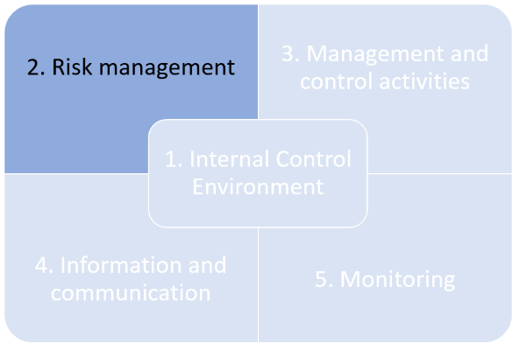 | Key question  Does the MA identify risks to the achievement of its objectives across the organisation? Are risks analysed as a basis for determining how they should be managed?

# | Source | Questions | YES/NO/Not Applicable | File reference, observation, comments, findings
 |  | Risk management system | Criterion 2
2.1 | ToR pillar assessment | Does the MA specify its objectives with sufficient clarity to enable the identification and assessment of the risks relating to the objectives?
2.2 | EGESIF_14-0013 | Are procedures in place to ensure that the MA conducts regular risk assessment exercises (at least once per year) which allows to identify, assess and address existing or potential issues that may hamper the achievement of the objectives?  If yes:  - Who performs them?  - At what level are they performed? (organisational level, specific-activities level, etc.)  - What kind of risks are identified (internal, external)?  - Are they documented?
2.3 | EGESIF_14-0013 | Do the procedures foresee that the risk assessment is done on a regular basis and in the event of major modifications of the activities?
2.4 | ToR pillar assessment | Do the procedures foresee to:  - Identify events and risks affecting the achievement of the objectives?  - Analyse the significance of risks and the likelihood of their occurrence  - Determine actions and follow-up mechanisms needed in response to the risks?  - Implement and modify controls to respond to changes in identified risks?
2.5 | EGESIF_14-0013 | When carrying out a risk assessment, is it ensured that a fraud risk assessment is also addressed? (please see section 4.4, criterion 3(viii))
 |  | Conclusion | Adequate/Not adequate

Management and control

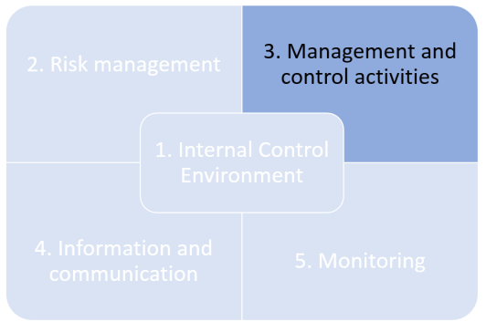 | Key question  Does the MA deploy effective and efficient management and control activities?

# | Source | Questions | YES/NO/Not Applicable | File reference, observation, comments, findings
3.1 | EGESIF_14-0013 | Have the procedures for management and control activities been prepared in writing for use of the staff and other concerned stakeholders?  Is there a formal procedure that controls the change, introduction and abandonment of procedures and their communication to staff and concerned stakeholders?
 |  | Project selection procedures | Criterion 3 (i)
3.2 | EGESIF_14-0013 | Are there procedures at selection stage for appraising, selecting and approving projects, including the compliance with the principles of transparency, equal treatment, non-discrimination, objectivity and fair competition?
3.3 | EGESIF_14-0013 & ToR pillar assessment | Is there a procedure to ensure that all applications received will be recorded?  Applications should be registered on receipt, evidence of receipt delivered to each applicant and records kept of the approval status of each application.
3.4 | EGESIF_14-0013 | Is there a procedure regarding declarations of confidentiality and non-conflict of interest to be filled by all persons participating in the evaluation procedures?
3.5 | EGESIF_14-0013 & TESIM | Shall the projects be selected and awarded on the basis of pre-announced selection and award criteria, which will be defined in an evaluation grid? In particular, is there a procedure to ensure that all applications will be evaluated in accordance with the applicable criteria and that the same rules and conditions shall be applied to all applicants?  The evaluation should be applied consistently, the criteria and scoring used should be approved by the JMC and mentioned in the calls, the results should be documented, the substance of the applications, as well as the financial, administrative and operational capacities of the applicants should be adequately evaluated.
3.6 | TESIM | Are there specific tools to ensure that all evaluators assessing the applications will possess the required expertise and independence?
3.7 | TESIM | Shall the grants be subject to ex ante and ex post publicity rules, i.e. shall adequate information be provided to (potential) beneficiaries and general public?
3.8 | TESIM | Are the decisions on the acceptance or rejection taken by the JMC on the basis of an evaluation report or in case the final decision is not in accordance with the evaluation report, the decision is explained in sufficient detail by the JMC?
3.9 | EGESIF_14-0013 | Is there a procedure to ensure that the decisions taken on the acceptance or rejection of applications will be communicated to applicants in writing?  If the grant requested is not awarded, is the MA bound to providing the reasons for the rejection of the application with reference to the selection and award criteria that are not met?
3.10 | EGESIF_14-0013 | Is the appeal procedure and related decisions adequately communicated to all applicants?
3.11 | TESIM | Are there adequate procedures for project contracting, ensuring that no substantial modifications are made to the proposals, so that the award decision is not put into question?
 |  | Contract management procedures | Criteria 3 (ii) & (vi)
3.12 | EGESIF_14-0013 | Does the procedure ensure effective communication to applicants/beneficiaries of their rights and obligations?  In particular, do these procedures adequately deal with the requirements of article 180 of the Rules of Application of the Financial Regulation (Commission Delegated Regulation (EU) 1268/2012) and articles 40 and 43 of the IR.
3.13 | TESIM | Are there adequate procedures to ensure the enforcement of rights and obligations to all project beneficiaries, e.g. through a partnership agreement or the co-signature of the grant contract by all beneficiaries?
3.14 | EGESIF_14-0013 | Is there a clear strategy to ensure that beneficiaries have access to clear and unambiguous information on project implementation requirements and receive appropriate level of guidance, e.g. through mentoring from the JTS/BO, leaflets, manuals, booklets, seminars, workshops and web-site?
3.15 | TESIM | Are there specific provisions for the modification of the grant contracts, either through an addendum of the grant contract or through a formal approval by the MA?
3.16 | TESIM | Are there adequate procedures to ensure that any grant contract modification does not put into question the grant award procedures and respect the principle of equal treatment of applicants?
3.17 | TESIM | Are there national procedures in ENI CBC partner countries to ensure effective implementation of the project by the beneficiaries, for example (when relevant):  - Registration procedures, where relevant  - Tax and customs exemption  - Opening bank accounts in Euro, at least for Lead Beneficiaries  - Transferring Euro abroad, either to other beneficiaries (in the case of lead beneficiaries), to contractors (in case of secondary procurement) or to the MA (in case of recovery)  - Derogation of national procurement rules, where included in the Financing Agreement  - Integration of project budget in the budget of public institutions, where relevant  - Anti-fraud and anti-corruption measures for prevention, detection, correction/punishment and notification, as required by the Financing Agreement
 |  | Verification procedures | Criteria 3 (iii) & (vi)
3.18 | TESIM | Are there procedures to ensure that reliable independent auditors or competent public officers are appointed for the verification of the expenditure and revenue, in accordance with the requirements set out in article 32 of the ENI CBC IR?
3.19 | TESIM | Is there a clear strategy to ensure that auditors and/or competent public officers have access to clear and unambiguous information on programme requirements and receive an appropriate level of guidance (training seminars, ToR for expenditure verification, web-site, etc.)?
3.20 | TESIM | Are there procedures to ensure that an examination of all declared expenses and revenues by beneficiaries shall be performed on the basis of an agreed-upon procedure which will be undertaken in accordance with the standards indicated in article 32 of the ENI CBC IR?  For public officers, are those procedures and standards laid down at national level taking account of international standards?
3.21 | EGESIF_14-0013 | Are there adequate procedures by the MA (supported by JTS if relevant) to perform its own administrative verifications for each payment request by beneficiaries pursuant to point (a) of article 26(5) and to point (a) of article 26(6) of the ENI CBC IR, that is verifying that services, supplies or works have been performed, delivered and/or installed and whether expenditure declared by the beneficiaries has been paid by them and that this complies with applicable law, programme rules and eligibility requirements for support of the projects, as defined in the grant contract?
3.22 | EGESIF_14-0013 | Do the procedures ensure that the MA (supported by JTS if relevant) performs its own administrative verifications for each payment request by beneficiaries pursuant to point (b) of article 26(5) and to point (a) of article 26(6) of the ENI CBC IR, that is verifying that beneficiaries involved in project implementation maintain either a separate accounting system or a suitable accounting code for all transactions relating to a project?
3.23 | TESIM | Does the procedure for administrative verifications ensure that they are performed before authorising any interim pre-financing or final balance payment to the grant beneficiaries?
3.24 | EGESIF_14-0013 | Do the procedures ensure that the MA (supported by JTS if relevant) performs its own on-the-spot verifications pursuant to point (a) of article 26(5) and to point (b) of article 26(6) of the ENI CBC IR, that is verifying that services, supplies or works have been performed, delivered and/or installed and whether expenditure declared by the beneficiaries has been paid by them and that this complies with applicable law, programme rules and conditions for support of the projects?
3.25 | EGESIF_14-0013 | Do the procedures to ensure that the frequency and coverage of the on-the-spot verifications shall be proportionate to the amount of the grant to a project and the level of risk identified by these verifications and audits by the Audit Authority for the management and control systems as a whole, in accordance with article 26(6) of the ENI CBC IR?  In particular, do the procedures ensure that an annual plan is defined for on-the-spot verifications based on a risk assessment and on an adequate sample of projects?
3.26 | EGESIF_14-0013 | Is it specified whether the on-the-spot verifications will take place at the premises of the lead beneficiary only or also at the premises of some or all other project beneficiaries?
3.27 | EGESIF_14-0013 | Are there written procedures and comprehensive check-list to be used by the MA in its verifications in order to detect irregularities?
3.28 | EGESIF_14-0013 | Do the procedures ensure that when carrying out its verifications, the MA is assisted by the control contact points? In particular, are there adequate procedures to ensure that the participating countries take all possible measures to support the MA in its control tasks, in accordance with article 32 of the ENI CBC IR?
3.29 | EGESIF_14-0013 | Do the procedures ensure that MA will keep record of:  - Each verification, stating the work performed, the date and the results of the verification and,  - The follow-up of the findings detected, including the measures taken in respect of the irregularities detected?
3.30 | EGESIF_14-0013 | Are there procedures foreseeing how the relevant information on recurrent irregularities and/or deficiencies detected and their follow-up is transmitted to the management level of MA, as well as other relevant bodies?
3.31 | TESIM | Are there procedures for the communication of the irregularities to EC?
 |  | Procedures for payments to beneficiaries | Criterion 3 (iv)
3.32 | EGESIF_14-0013 | Are there adequate procedures for processing requests for payments from beneficiaries and authorising them, in accordance with article 63 of the ENI CBC IR?  In particular:  - Is each step of the procedure by which requests for payment are received, verified and validated described?  - Is each step of the procedure by which payments to beneficiaries are authorised, executed and accounted for described?  - Is the unit and/or body performing each step of the procedure indicated?  - Is adequate separation of functions for the process ensured?  - Has a flowchart been provided, describing the process and indicating all the units and/or bodies involved?  - Are all needed and relevant supporting documentation attached?  - Is the procedure developed in view of respecting the request for a quick payment of article 63 of the ENI CBC IR?
3.33 | EGESIF_14-0013 | Is there a procedure to ensure the recovery of the unduly paid amounts of the EU contribution?
 |  | Electronic data systems | Criterion 3 (v)
3.34 | EGESIF_14-0013 | Is there an adequate system in place or foreseen to ensure collecting, recording and storing electronically data on each project, including at least:  - Data on all project beneficiaries  - Data for monitoring and evaluation, including indicators  - Data for financial management, verification and audit
3.35 | EGESIF_14-0013 | Are there adequate procedures to ensure:  - The security and maintenance of the computerised system, data integrity, data confidentiality, the authentication of the sender and storage of documents and data?  - The protection of individuals with regard to the processing of personal data?
3.36 | EGESIF_14-0013 | Is a description including a flowchart of the management information system (MIS) supplied, showing their elements and the links between them, and whether they are internet-based or networked?
3.37 | EGESIF_14-0013 | Has the system (totally or partially) been used in the previous programming period? If yes, was it considered reliable (e.g. has it been audited)?
3.38 | EGESIF_14-0013 | Does the MIS description deal adequately with the segregation of functions?
3.39 | EGESIF_14-0013 | Indicate whether the MIS is totally operational for gathering reliable data?  If not or partially, assess based on the planning obtained from the MA whether the system will be operational in due time.
 |  | Anti-fraud measures | Criterion 3 (vii)
3.40 | EGESIF_14-0013 | Are there adequate procedures to ensure the putting in place of effective and proportionate anti-fraud measures taking into account the risks identified?  Are these measures structured around the 4 key elements of the anti-fraud cycle (prevention, detection, correction and prosecution)?  Is there a procedure for the monitoring and updating of the anti-fraud measures?
3.41 | EGESIF_14-0013 | Are there adequate and proportionate preventive measures, tailored to specific situations, in order to mitigate the residual risk of fraud to an acceptable level, such as:  - mission statement  - tone from the top communication  - allocation of responsibilities  - training and awareness raising actions  - data analytics  - up-to-date awareness of fraud warming signs and fraud indicators  Does the procedure ensure putting in place additional measures including indicative actions to be taken and a timetable for their implementation, in case the fraud risk assessment shows that there is a residual (net) risk of fraud, which is significant or critical due to existing controls being insufficient to mitigate the identified fraud risks?
3.42 | EGESIF_14-0013 | Is there an adequate procedure to ensure that the risk assessment:  - is carried out for the first time within satisfactory deadlines and  - is repeated during the programming period, its frequency depending on risk levels and the actual instances of fraud?
3.43 | EGESIF_14-0013 | Is there an adequate procedure to ensure that the fraud risk assessment covers the specific risks in relation to:  - the project selection  - the implementation and verification of the operations  - the authorization of payments  Have other specific fraud risks not covered by this check-list been identified? If yes, which are these risks?
3.44 | EGESIF_14-0013 | Is there a procedure in place for whistle-blowing by any person (i.e. concerning the right to inform an external independent contact point of irregularities or wrongdoing?)
3.45 | EGESIF_14-0013 | Does the procedure related to the process of the fraud risk assessment ensure that:  - the assessment team is appropriately composed of members from representative departments?  - there is evidence that sources of information such as audit reports, fraud reports and self-assessments are taken into account during the risk assessment process?  - the self-assessment process is clearly documented, allowing for a clear view of the conclusion reached?  - is there evidence that senior management has adequate oversight and/or involvement in the process and approved the net level of risk exposure?
3.46 | EGESIF_14-0013 | In case of suspected case of fraud, does the procedure ensure that adequate reporting measures will be taken, in particular the coordination with the AA, the relevant national authorities, EC and OLAF?
3.47 | EGESIF_14-0013 | Are there adequate procedures in place for following up any suspected cases of fraud and related recoveries of funds spent in a fraudulent manner?  Are there follow-up procedures to review any processes, procedures and controls connected to the potential or actual fraud and feed into the subsequent review of the fraud risk assessment?
 |  | Programme accounts | Criterion 3 (viii)
3.48 | TESIM | Are there a flowchart and an adequate procedure by which statements of expenditure are drawn up, verified and submitted to the Commission, including a procedure to ensure sending of the annual report by 15th February following the end of the previous accounting year, in accordance with article 68 of the ENI CBC IR?
3.49 | ToR pillar assessment & TESIM | Is there a description of the accounting standards used by the MA, in accordance with articles 141 and 143 of the Financial Regulation and following the International Standards for Public Sector Accounting (ISPAS)?
3.50 | ToR pillar assessment & TESIM | Is there a description of the accounting principles to be used by the MA for the preparation of the financial statements, in accordance with articles 145 and 146 of the Financial Regulation and following the International Financial Reporting Standards (IFRS)?
3.51 | EGESIF_14-0013 | Is there a description of the accounting system in computerised form to be set up and used as a basis for the preparation of the financial statements and the annual report to EC?  Is the system already operational? If not, when is it planned to be operational?  Has the system already been used in the previous programming period? If yes, was it audited in the past and considered reliable?
3.52 | EGESIF_14-0013 | Is the level of detail of accounting system indicated, including:  - whether it shows total projects’ expenditure by Thematic Objective  - whether it allows for traceability of the allocation of the available public funds?  - whether it allows allocation of payments made to individual beneficiaries in the year concerned?  - amounts recoverable and amounts withdrawn following cancellation of all or part of the contribution for a project?
3.53 | TESIM | Is it ensured that the drawing of the accounts take into account the results of all audits and to ensure that they are true, complete and accurate?
 |  | Audit trail and archiving system | Criterion 3 (ix)
3.54 | EGESIF_14-0013 | Is there an adequate procedure to ensure that the MA will keep record of:  - Each verification, stating the work performed, the date and the results of the verification and  - The follow-up of the findings detected including the measures taken in respect of irregularities detected?
3.55 | EGESIF_14-0013 | Is there a procedure to ensure that a record is kept by the MA of the identity and location of bodies holding the supporting documents relating to expenditure and audits?
3.56 | EGESIF_14-0013 | Are there documents to ensure that all documents required for an adequate audit trail are kept in accordance with article 70 of the ENI CBC IR?  In particular, is there an adequate procedure dealing with:  - The type of documents which have to be archived  - The period during which these documents have to be archived  - The format in which the documents are to be held  Are there instructions given on keeping supporting documents available by beneficiaries and programme bodies?
3.57 | EGESIF_14-0013 | Is the description of the audit trail sufficient to demonstrate that it:  - Permits the reconciliation of the aggregate amounts declared to the EC with the detailed accounting records and supporting documents held by the beneficiaries and the programme bodies?  - Permits the verification of the payment of the EU contribution to the beneficiaries  - Permits the verification of the application of the selection criteria established by the JMC  - Contains in respect of each awarded project as appropriate the description of the action, the financial plan and budget, the logframe, the documents relating to the grant approval, progress reports and reports on verifications and audits carried out.
3.58 | EGESIF_14-0013 | Are there procedures to ensure that the above-mentioned project documents are kept at appropriate management level?
3.59 | EGESIF_14-0013 | Is there a procedure to ensure that the accounting records are kept at appropriate management level and provide detailed information on expenditure and revenue actually incurred for each projects by beneficiary?
3.60 | EGESIF_14-0013 | Are there adequate procedures to ensure an adequate trail by maintaining accounting records in computerised form on amounts recovered, amounts to be recovered, amounts withdrawn from payment requests, amounts irrecoverable and amounts related to projects suspended?  Are these records traceable by project and beneficiary?
3.61 | EGESIF_14-0013 | Does the audit trail allow reconciliation of the expenditure declared to EC with the expenditure statements received from all the programme bodies managing TA funds?
 |  | Management declaration of assurance | Criterion (x)
3.62 | EGESIF_14-0013 | In accordance with article 68 of the IR, does the MA have adequate procedures in place:  - To draw up the management declaration of assurance?  - To draw up the report on the controls carried out and weaknesses identified?  - To draw up the annual summary of final audits and controls?
3.63 | EGESIF_14-0013 | Are there procedures ensuring that the annual accounts and reports, the management declaration and all the relevant supporting documentation and information are made available in due time to the Audit Authority for the purpose of its assessment?
3.64 | EGESIF_14-0013 | Is adequate documentation of the work carried out in preparation of the management declaration, the report on controls and the annual summary foreseen to ensure that:  - before submission to EC, payment requests are checked to guarantee that information included in the accounts is properly presented, complete and accurate?  - before submission to EC, payment requests are checked to confirm that they include only expenditure which is used for its intended purpose?  - the control systems put in place give the necessary assurances concerning the legality and regularity of the underlying transactions?
3.65 | EGESIF_14-0013 | Are there procedures to ensure that an adequate staffing will be implemented for the programme, providing assurance about the effective functioning of the systems?
3.66 | EGESIF_14-0013 | Are there procedures to ensure that system changes, exceptions to procedures, internal control weaknesses are applied or remedied properly, in accordance with internal rules?
3.67 | EGESIF_14-0013 | Are there procedures to ensure that the implementation of the programme is monitored on a regular basis mainly with respect to:  - selection of projects  - preparation and submission of projects  - tendering and awarding TA contracts  - project implementation
3.68 | EGESIF_14-0013 | Are there procedures to confirm the reliability of data relating to indicators, milestones and the progress of the programme?
3.69 | EGESIF_14-0013 | Are there procedures to ensure that effective and proportionate anti-fraud measures are in place and that the results of the measures are taken into account for the purpose of the management declaration?
3.70 | EGESIF_14-0013 | Are there procedures to ensure that the results of management verifications are reported in the annual summary?
3.71 | EGESIF_14-0013 | Are there procedures to ensure that the results of management verifications are duly taken into account to conclude on the effective functioning of the control system put in place and the legality and regularity of underlying transactions?
3.72 | EGESIF_14-0013 | Are there procedures to ensure that recommendations included in the final audit reports issued by the relevant audit bodies at programme and EU level are followed-up and implemented?
3.73 | EGESIF_14-0013 | Are there procedures to ensure that action is taken as regards areas of weaknesses and/or problems identified by the controls carried out?
 |  | Conclusion | Adequate/Not adequate

Information and communication

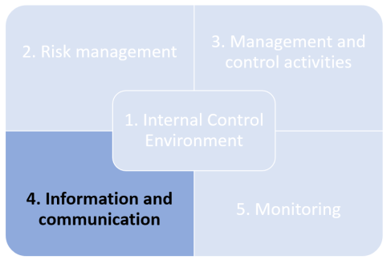 | Key question  Does the MA have controls and procedures in place which ensure reliable information – both internal and external (inbound and outbound) – in line with the applicable requirements and standards?

# | Source | Questions | YES/NO/Not Applicable | File reference, observation, comments, findings
 |  | The MA obtains or generates relevant information | Criterion 4 (i)
4.1 | ToR pillar assessment | Are there adequate procedures to obtain or generate and use relevant, quality information (internal and/or external sources) to compile the reports needed for adequate decision-making and fulfilment of the functions assigned by the IR?
4.2 | TESIM | For each one of the key processes and procedures during the programme cycle, is it defined how the information is identified, captured and inserted in the management and information system (MIS)?
4.3 | TESIM | For each one of the key processes and procedures during the programme cycle, is it identified the unit responsible for the collection and distribution of each piece of information?
4.4 | TESIM | Is information, both in MIS and on paper form, evaluated and classified based on level of integrity, confidentiality and availability? Are individuals with access to information trained to understand their responsibilities related to the information?
4.5 | ToR pillar assessment | Does the information generated by MA, either in MIS or on paper form cover qualitative aspects of implementation such as for example results and output indicators, implementation status and delays, key problems and issues?
4.6 | ToR pillar assessment | Does the information generated by MA, either in MIS or on paper form cover financial aspects such as budget – actual comparisons and analyses of expenditure incurred by thematic objective/priority / project?
 |  | The MA disseminates information internally | Criterion 4 (ii)
4.7 | ToR pillar assessment | Are there adequate procedures for internal communication of information, including objectives and responsibilities for internal control, necessary to support the functioning of internal control?
4.8 | ToR pillar assessment | Does management of MA/JTS receive regular reports on progress made on objectives and activities, both at programme and project level?  Is the level of reporting detail appropriate for the management needs? Is data summarized to facilitate decision making?
4.9 | TESIM | For each one of the key processes and procedures during the programme cycle, is it identified how the information is disseminated within MA and JTS/BO and among them?
4.10 | TESIM | For each of the key processes and procedures during the programme cycle, is it identified which unit is responsible for the internal dissemination of information?
4.11 | TESIM | Are formal methods used to communicate policies and procedures (e.g., manuals, training programs, written codes of conduct, and acceptable practices)?
4.12 | TESIM | Are employees kept informed of important matters (downward communication) and are able to communicate problems to persons with authority (upward communication)?  Is there effective functional coordination within the units (lateral communication)?
 |  | The MA disseminates information externally | Criterion 4 (iii)
4.13 | TESIM | For each one of the key processes and procedures during the programme cycle, is it identified how the information is disseminated to potential beneficiaries, beneficiaries, other programme structures, national authorities and EC?
4.14 | TESIM | For each one of the key processes and procedures during the programme cycle, is it identified who is responsible for the external dissemination of information?
4.15 | TESIM | Is there an executive information system for JMC members and National Authorities with the adequate level of detail for decision making, such as reporting on programme and project results through indicators?
 |  | Conclusion | Adequate/Not adequate

Monitoring
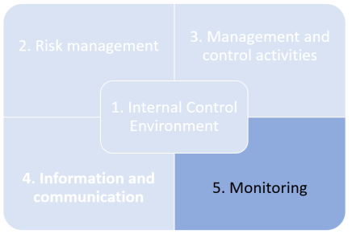 | Key question  Does the MA monitor the components of its internal control system regularly and effectively?

# | Source | Questions | YES/NO/Not Applicable | File reference, observation, comments, findings
 |  | Monitoring internal control | Criterion 5
5.1 | TESIM | Are key controls on the functioning of the systems identified, together with the persons responsible for carrying them out?
5.2 | TESIM | Is persuasive information (as defined in INTOSAI 9110) identified for each of the key controls?
5.3 | ToR pillar assessment | Does the MA routinely spot-check procedures to monitor the how internal control system is functioning?
5.4 | TESIM | Are these on-going procedures documented?
5.5 | TESIM | Is there a self-evaluation of the system carried out by the staff with responsibility over procedures?
5.6 | TESIM | Are the findings reported at the adequate level?
5.7 | TESIM | Are inquiries or complaints from stakeholders investigated and considered for internal control implications?
5.8 | TESIM | Does the MA periodically evaluate the accuracy, timeliness and relevance of its MIS?
5.9 | TESIM | Do the internal control procedures envisage an analysis of the nature and extent of errors and weaknesses identified in systems, as well as corrective action taken or planned?
 |  | (if MA has internal audit unit)
5.11 | ToR pillar assessment | Does the internal audit unit comply with the international professional standards and the code of ethics issued by the Institute of Internal Auditors (www.theiia.org)?
5.12 | ToR pillar assessment | Is the internal audit unit independent i.e. does it have freedom from conditions that threaten its ability to carry out internal audit responsibilities in an unbiased manner?
5.13 | ToR pillar assessment & TESIM | Does the internal audit unit present regular progress reports to the management of the MA?  Are findings and recommendations resulting from internal audit duly addressed (to senior management of the MA) and resolved?
 |  | Conclusion | Adequate/Not adequate

Final checks

# | Source | Questions | YES/NO/Not Applicable | File reference, observation, comments, findings
6.1 | EGESIF_14-0013 | Are all elements stipulated in the Annex of the Implementing Rules included in the DMCS?
6.2 | TESIM | Are all elements stipulated in article 30 of the Implementing Rules included in the DMCS?
 |  | Conclusion | Adequate/Not adequate

Overall assessment
Overall assessment of the internal control system
Objective(s) being considered for the scope if internal control |  | Considerations regarding management’s acceptable level of risk
Operations
Reporting
Compliance
Designation criteria |  | Present? (Y/N) | Functioning? (Y/N) | Explanation/Conclusion
Control environment
Risk assessment
Control activities
Information and communication
Monitoring
Are all components operating together in an integrated manner?
Is the overall system effective?
Overall conclusion

Audit opinion

Type of opinions by the independent audit body
The Managing Authority should seek to resolve all outstanding issues to enable the independent audit body to provide an unqualified opinion. The independent audit body will need to exercise professional judgement in order to assess the results and the seriousness of any shortcomings identified in order to provide an appropriate audit opinion. The following guidance may be taken into account:
- Non-compliance with one or more designation criteria relating to the system should lead to either a qualified or an adverse opinion.
- In case of partial compliance with one or more designation criteria relating to the system, the seriousness and extent of these shortcomings should be assessed by the independent audit body, which will decide whether a qualified opinion or an adverse opinion has to be formulated.
An adverse opinion should be issued where the independent audit body considers that the number and seriousness of shortcomings with regard to the key requirements of the management and control systems result in wide-ranging non-compliance with the requirements of the Implementing Rules.
In accordance with internationally accepted auditing standards, the independent audit body may, without qualifying its opinion, include an emphasis of matter paragraph in its audit opinion.
Where the independent audit body’s opinion on the managing authority is:
- Adverse or qualified, the Member State should not designate that body.
- Unqualified, the Member State should designate the body.

Summary table of the independent audit body
The findings identified in the present checklist are to be summarised in the table below and serve as a primary source of information for the IAB when issuing its opinion on each body. This table is part of the report of the IAB.

Findings # | Designation criteria affected | Section of DMCS affected | Completeness and accuracy of description (Y/N) | Conclusion (unqualified, qualified, adverse) | Shortcomings | Recommendations / corrective measures | Timeframe agreed for implementation of corrective measures

Model of audit report
This model for the report of an IAB, as well as the model of opinion, is based in Annex IV of Commission Implementing Regulation (EU) No 1011/2014 of 22 September 2014 laying down detailed rules for implementing Regulation (EU) No 1303/2013 (…).
1. Introduction
1.1 Identify the objective of the report, i.e. to set out the results of the assessment of the compliance of the Managing Authority with the designation criteria relating to the components of internal control set out in the annex to the ENI CBC IR, in order to express an opinion on their compliance with the designation criteria.
1.2 Identify the scope of the report i.e. the body(ies) covered and their compliance with the designation criteria.
1.3 Indicate the body that has prepared the report (‘Independent Audit Body’) and specify if it is the Audit Authority for the Joint Operational Programme covered.
1.4 Indicate how the functional independence of the Independent Audit Body from the Managing Authority is ensured.
2. Methodology and scope of the work
2.1 Indicate the period and timeframe of the audit (date when the final description of the management and control systems was received by the Independent Audit Body, date when the audit started and ended, and resources allocated).
2.2 Specify the extent of the use of previous audit work for the 2007-2013 programming period, where applicable.
2.3 Specify the extent of the use of audit work carried out by other bodies (either external audit companies or members of the Group of Auditors) and the quality control performed on such audit work with respect to the adequacy of the work.
2.4 Describe the work done for assessing the fulfilment by the Managing Authority being designated by [Member State] of the criteria, covering among other elements, the following:
2.4.1. Examination of the description of the management and control systems, in accordance article 30 of the IR.
2.4.2. Examination of other relevant documents concerning the system; indicate any review of laws, ministerial acts, circulars, internal procedure/other manuals, guidelines and/or checklists.
2.4.3. Interviews with the staff in the relevant programme bodies. Include description of the method and criteria for selection, what subjects have been covered, how many interviews have taken place and who has been interviewed.
2.4.4. Where functions have been delegated by the Managing Authority to other bodies, describe the audit work done to verify that the capacities of these bodies to carry out delegated tasks, that they have sufficient supervisory procedures in place over these intermediate bodies and any other relevant audit work.
2.5 Indicate if any contradictory procedures have taken place prior to issuing this report and indicate the relevant authorities/bodies.
2.6 Confirm that the work has been carried out taking account of internationally accepted audit standards.
2.7 Identify if there were any limitation of scope, in particular the ones affecting the opinion of the independent audit body.

Model of audit opinion
To ........................................................... (Member State authority/body)
INTRODUCTION
I, the undersigned, representing [name of the independent audit body] as the body functionally independent from the Managing Authority, responsible for drawing up a report and opinion setting out the results of an assessment of the compliance of the Managing Authority with the designation criteria set out in the Annex of the Regulation (EU) No 897/2014 for [name of Joint Operational Programme, Decision Nº ] (hereinafter ‘the programme(s)’), have carried out an examination in accordance with article 25 of the Regulation (EU) No 897/2014.
SCOPE OF THE EXAMINATION
The examination covered the [indicate the bodies], as described in section 1 of the attached report. The extent and scope of the examination is detailed in section 2 of the attached report. Among other aspects described in this report, the examination was based on description of the management and control systems, drawn-up by and under the responsibility of the Managing Authority and received on [dd/mm/yyyy].
OPINION (Unqualified opinion)
On the basis of the examination referred to above, it is my opinion that the Managing Authority being designated for the programme comply with the designation criteria relating to the components of the internal control set out in the Annex to Regulation (EU) No 897/2014.
Or (Qualified opinion)
On the basis of the examination referred to above, it is my opinion that the Managing Authority being designated for the programme comply with the designation criteria relating to the components of the internal control set out in the Annex to Regulation (EU) No 897/2014, except in the following respects ()..........................................................................................
My reasons for considering that this authority does not comply with the designation criterion(a) and my assessment of the seriousness are as follows ():...............................................................................................
Or (Adverse opinion)
On the basis of the examination referred to above, it is my opinion that the Managing Authority being designated for the programmes does not comply with the designation criteria relating to the components of the internal control set out in the Annex to Regulation (EU) No 897/2014. This adverse opinion is based on ................................................................................................................................................... ()
Emphasis of matter (to be used as appropriate) [The independent audit body may also include emphasis of matter, not affecting its opinion, as established by internationally accepted auditing standards.]
Date Signature

Regulation (EU) No 1303/2013.
Article 21 of the ETC regulation says: “Member States participating in a cooperation programme may designate the managing authority as also being responsible for carrying out the functions of the certifying authority”
See INTOSAI GOV. 9100 “Guidelines for Internal Control Standards for the Public Sector” and “Executive Summary of Internal Control - Integrated Framework” by COSO (Committee of Sponsoring Organizations of the Treadway Commission)
It corresponds with the key question to Pillar 1 of the guidance issued by Europeaid
See article 32 of the Financial Regulation
Regulation (EU, EURATOM) No 883/2013 of the European Parliament and of the Council of 11 September 2013 concerning investigations conducted by the European Anti-Fraud Office (OLAF).
Use COSO Integrated Framework, INTOSAI GOV 9100 and INTOSAI GOV 9310 for more details on the need of objectives in the risk management.
See TESIM “Guide on Management Information Systems” for further information.
Annex A1 of TESIM “Guide on Management Information Systems” may be used as a source of inspiration.
Taking into account the COBIT (Control Objectives for Information and related Technology) framework and the internationally accepted standards: ISO/IEC standard 27001:2013 and ISO/IEC standard 2007:2013. Annex A2 of TESIM “Guide on Management Information Systems” may be used as a source of inspiration.
See “Guidance note on fraud risk assessment and effective and proportionate anti-fraud measures” Ref. Ares(2013)3769073.
See TESIM “Guide on programme accounts, reporting to EC and audit”
See INTOSAI GOV 9100 and 9110 for further details.
As requested by article 68 of the ENI CBC IR.
Indicate the designation criteria with which the MA does not comply.
Indicate the reason(s) for the reservation(s) entered on each designation criteria.
Indicate the reason(s) for the adverse opinion on each aspect.

