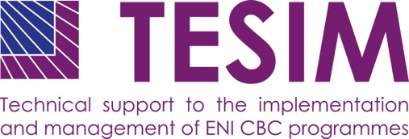
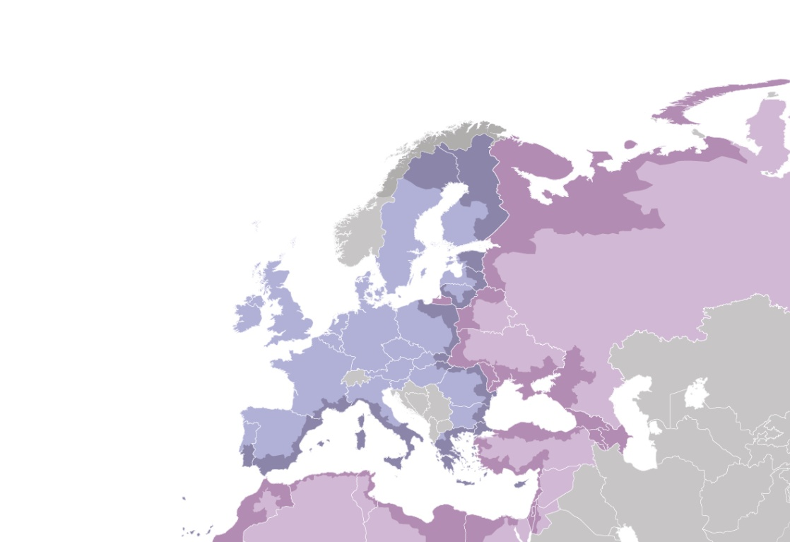
A project funded by the European Union |  | Implemented by a consortium led by

Annual monitoring and evaluation plan

of ENI CBC programmes

  - Template and suggestions for the contents

Introduction
Monitoring and evaluation are essential for programme management, as they serve multiple purposes during the entire cycle of the programme planning, implementation and closure, both on the daily as well as on the strategic management level. There are different monitoring and evaluation tools at the disposal of a programme, and it is therefore important to carefully plan when, how and by whom they are implemented in order to gain most from the complementarities among them.
The ENI CBC programmes are requested to plan their monitoring and evaluation activities both for the entire duration of the programme (to be described in the Joint operational programme) as well as on a yearly basis (by drawing up an annual monitoring and evaluation plan). These plans have to follow the Commission’s guidance and evaluation methodology.
Programmes should view the monitoring and evaluation plan as a tool that structures their thinking process in a strategic way and supports building a common agreement within the programme on the monitoring and evaluation activities to be implemented. Therefore the development of the annual plan starts with a reflection on the monitoring and evaluation activities implemented in the previous year and the definition of objectives for the year to come. They will serve as a basis when planning the use of monitoring and evaluation tools and the allocation of the necessary resources.
This document provides programmes with a suggested template for the annual monitoring and evaluation plan, taking into account the available guidance and the outcomes of the monitoring and evaluation network events.

Template for the annual monitoring and evaluation plan
Documents to be taken into account when developing the plan:
- ENI CBC Implementing Rules,
- Joint operational programme,
- DG NEAR “Guidelines on linking planning/programming, monitoring and evaluation”,
- Description of management and control system.
- Management of the monitoring and evaluation plan
- Describe which programme body (unit) has the overall responsibility for drafting the plan and implementing it.
- Describe when and how the plan is approved, reviewed and updated.

- Overview of the project and programme monitoring and evaluation activities in the previous year
- Shortly describe the main monitoring (including ROM) and evaluation activities carried out in the previous year, as well as the resources used for their implementation.
- Provide an own evaluation of the implemented activities and lessons learnt for the future.
- Describe how results of the external monitoring and evaluation activities (e.g. ROM, mid-term evaluation, etc.) have been taken into account and how the risks identified in the risk management exercise have been addressed.

- Overview of the project and programme monitoring and evaluation activities in the year for which the plan is developed
- State the monitoring and evaluation objectives, (e.g. to have a well informed decision making process when launching calls for proposals; to have an overview of project progress at any moment in time, etc.) based on the implementation stage of the programme and its projects.
- Describe which information needs (e.g. feeding the decision-making process at management level, accountability on the use of resources) can be satisfied by using information available (e.g. from previous monitoring or existing evaluations), and which ones require action and need to enter the plan.

- Monitoring and evaluation tools
- Mention tools (e.g. day-to-day monitoring, result-oriented monitoring, on-the-spot checks, monitoring visits, mid-term evaluation, etc.) that will be used by the programme, as well as complementarities and links among them. Explain how these tools will contribute to the achievement of the monitoring and evaluation objectives.
- Identify the procedures that need to be developed describing how monitoring and evaluation activities will be implemented.
4.1 Planned monitoring at project level
- Describe how the programme requirements regarding the internal monitoring of projects during their implementation will be explained to the applicants and beneficiaries (e.g., in the guidelines for grant applicants, during the trainings, etc.).
- List criteria based on which the risk assessment of the projects will be carried out, as well as monitoring tools that will be applied based on the identified level of risk (e.g., review of project narrative and financial reports, periodic phone calls with the projects on their state of play, following the projects in the social media, participation in the main project events, monitoring visits, project ROM, etc.), including the involvement of the different programme bodies and national authorities.
- Fill in the table in the Annex 1 with information on the contracted projects, their level of risk and monitoring tools to be applied in accordance with the identified risk. In case you would like to suggest projects for an EC ROM mission, please state it in the “Monitoring activities” column.
- In case EC ROM mission(s) have been carried out on the projects, describe how the programme plans to take their results and findings into account, and how the ROM recommendations will be followed up.

4.2. Planned monitoring activities at programme level
- Describe specific activities for monitoring the progress in the programme strategy implementation
- Describe how the measurement of the key performance indicators will be implemented.
- Describe how the result-oriented monitoring of the programme will be implemented
- If any EC ROM missions and/or evaluation activities have taken place, describe how conclusions of these will be taken into account in the monitoring and evaluation activities of the programme.

4.3. Planned evaluations at programme and project level
- List the evaluation exercise(s) that are planned in the projects.
- List evaluations of the projects to be implemented by the programme, for example, on projects with a budget over 5 MEUR.
- List the planned programme evaluations (e.g. mid-term evaluation, internal analysis of the results of the previous call(s) for proposals before planning the next call, etc.)
- For the programme evaluations planned above, fill in the table in Annex 2 with the requested details (add as many columns as necessary):
- If applicable, describe how the previous evaluations (either by the programme itself or by the EC) will be taken into account.

- Communicating on the monitoring and evaluation activities
- Describe who, when and how will be informed about the plan and about the outcome of the monitoring and evaluation activities (e.g., Joint Monitoring Committee, other programme stakeholders, project beneficiaries, governments of countries co-financing programme, wider public, etc.).

Annex 1 – List of projects to be monitored (project portfolio)

Project title and/or index | Total project budget | Responsible monitoring officer at the JTS/MA | Risk level of the project (low/medium/high) | Brief description of the risk | Planned monitoring activities (i.e day-to-day monitoring, result-oriented monitoring, on-the-spot checks, monitoring visits, etc) | Timing of the monitoring activities

Annex 2 - Planned evaluations at programme and project level

Title and object (programme, strategy, project) of the evaluation
Purpose of the evaluation
Type of the evaluation (programme, project, thematic)
Key elements of the evaluation
Time frame for the evaluation
Type of resources mobilised (internal and/or outsourced)

Estimated costs
When evaluation results have to be available

Article 78.2 of the ENI CBC Implementing Rules.
DG NEAR “Guidelines on linking planning/programming, monitoring and evaluation”.
In accordance with Article 18.3 of the Rules of Application of the Financial Regulation 1268/2012.

